

PROJECT BASED LEARNING (PBL - 4)
(CSP390)
ResoHub: Smart Corporate Knowledge Management & Learning System

B.TECH IT 3rd YEAR
SEMESTER: VI
SESSION: 2025-2026
Submitted By:
Himanshu Singh (2023370139)
Ragini Singh (2023445411)

B.Tech in Information Technology

Submitted to

Dr. Deepthi P S
Associate Professor
Computer Science and Applications
School of Computing Science and Engineering

DEPARTMENT OF COMPUTER SCIENCE & APPLICATIONS
SHARDA SCHOOL OF COMPUTING SCIENCE & ENGINEERING
SHARDA UNIVERSITY, GREATER NOIDA

DECLARATION OF THE STUDENT
We hereby declare that the project work entitled “ResoHub: Smart Corporate Knowledge Management & Learning System” is an outcome of our own efforts. This work has been carried out under the supervision of Dr. Deepthi P S.
We affirm that the content of this project represents our original work, ideas, and findings. It has been prepared with sincerity, dedication, and academic integrity. The data, results, and conclusions presented in this report are authentic to the best of our knowledge.
The project is submitted to Sharda University as part of the academic requirements for the Project-Based Learning-4 (PBL-4) course of the Bachelor of Technology in Information Technology for the academic year 2025–26. We also declare that this project report has not been submitted previously to any other university or institution for any academic purpose.

Name: Himanshu Singh
System ID: 2023370139

Name: Ragini Singh
System ID: 2023445411

CERTIFICATE

This is to certify that Himanshu Singh (2023370139) and Ragini Singh (2023445411), students of Sharda University, have successfully completed the Project-Based Learning (PBL - 4) work entitled “ResoHub: Smart Corporate Knowledge Management & Learning System” in partial fulfilment of the requirements for the Bachelor of Technology in Information Technology degree examination for the academic year 2025–2026 under Sharda University.

We further certify that the contents of this project report are an authentic record of the work completed by the above students during the academic period 2025–2026 and that the work has not been submitted to any other university or institution for the award of any degree or diploma.

Dr. Deepthi P S Dr. Rajneesh Kumar Singh
Associate Professor Head of the Department
Department of CSA Department of CSA

ABSTRACT
In the fast-paced landscape of modern corporate environments, effective training and knowledge transfer are frequently hindered by fragmented systems. Critical technical guidelines, Standard Operating Procedures (SOPs), and project documentation often end up scattered across emails, local drives, and disconnected platforms. This disorganization not only creates a steep and frustrating learning curve for new employees but also places a heavy burden on senior staff, who must repeatedly pause their own work to provide manual mentorship.
To address these core challenges, this project introduces "TCS ResoHub"—a centralized, smart Learning Management System (LMS) built to modernize how corporate knowledge is stored and shared. ResoHub acts as a single, reliable source of truth, offering tailored workflows for different users. Subject Matter Experts (SMEs) are provided with seamless tools to curate and upload structured training modules, while Associates can easily navigate and consume these resources through a clean, intuitive dashboard.
The standout innovation of this platform is the integration of an AI-powered Chatbot. Acting as a 24/7 virtual mentor, the AI empowers users to instantly query complex technical documentation and receive precise, context-aware answers. This feature dramatically reduces the dependency on senior developers for routine questions, allowing them to remain focused on high-level tasks. Furthermore, the system is enriched with intelligent, user-centric features such as robust role-based access control, personalized "Recently Viewed" tracking, and a "Favorites" system to keep essential resources just a click away. Ultimately, by digitizing and intelligently organizing institutional knowledge, ResoHub significantly shortens the "time-to-productivity" for new hires, fostering a culture of continuous, self-paced, and highly efficient learning.

ACKNOWLEDGEMENT
We would like to express our sincere gratitude to Sharda University for providing us with the opportunity and facilities to carry out this Project-Based Learning (PBL) work successfully.
We extend our heartfelt thanks to our Project Guide, Dr. Samta Rani for his/her valuable guidance, constant encouragement, and constructive suggestions throughout the course of this project. his/her support and timely feedback played a crucial role in the successful completion of our work.
We are also grateful to the PBL Course Instructor Dr. Deepthi P S, and the Head of the Department of Computer Science and Applications, Dr. Rajneesh Kumar Singh for their continuous support and for providing a conducive academic environment.
We would like to thank all the faculty members of the Department of Computer Science and Applications for their cooperation and guidance during the academic year.
Finally, we express our sincere thanks to our parents, friends, and classmates for their motivation, encouragement, and support, which helped us complete this project successfully.

Name: Himanshu Singh
System ID: 2023370139

Name: Ragini Singh
System ID: 2023445411

TABLE OF CONTENTS
ABSTRACT [1]
ACKNOWLEDGEMENT [2]
CHAPTER 1 INTRODUCTION [4]
1.1 BACKGROUND
1.2 PROBLEM STATEMENT
1.3 OBJECTIVES
1.4 SCOPE
CHAPTER 2 LITERAURE REVIEW [7]
2.1 REVIEW OF EXISTING WORKS
2.2 IDENTIFIED RESEARCH GAPS / KEY FINDINGS
2.3 MOTIVATION FOR THE PROPOSED SYSTEM
CHAPTER 3 METHODOLOGY [9]
3.1 REQUIREMENTS
3.2 SYSTEM ARCHITECTURE
3.3 DATA SET
3.4 ALGORITHM/PROCESS/FLOW
3.5 TOOL AND SOFTWARE USED
CHAPTER 4 RESULTS AND DISCUSSION [14]
4.1 IMPLEMENTATION RESULTS
4.2 SCREENSHOTS
4.3 PERFORMANCE ANALYSIS
4.4 DISCUSSION
CHAPTER 5 CONCLUSION AND FUTURE SCOPE [18]
REFERENCES [20]
APPENDIX I: PLAGIARISM REPORT [21]
APPENDI II: PROJECT OUTCOMES [22]

CHAPTER 1

INTRODUCTION

1.1 BACKGROUND

In today’s fast-paced Information Technology sector, the way an organization handles employee onboarding and continuous learning can make or break its competitive edge. As large enterprises grow, they naturally generate a massive footprint of institutional knowledge—ranging from complex architectural blueprints to everyday Standard Operating Procedures (SOPs) and technical documentation.

Historically, these crucial resources have been scattered across endless email threads, fragmented cloud storage drives, or outdated legacy intranet sites. This chaotic distribution creates isolated "knowledge silos." In these silos, valuable information technically exists, but it is frustratingly inaccessible to the people who actually need it. However, the recent and rapid advancements in modern web development and Artificial Intelligence present a unique opportunity to completely rethink this model. By moving away from static, disconnected file repositories, we can build a unified, intelligent portal that doesn't just store documents, but actively guides and assists employees throughout their daily learning journey.

1.2 PROBLEM STATEMENT

Despite the availability of various corporate training tools on the market, most existing systems suffer from extreme rigidity and a poor user experience. Currently, when new associates join a project, they are often forced to waste an excessive—and expensive—amount of time digging through deeply nested, unorganized folders just to find basic software configurations or project guidelines.

Because traditional documentation is often dense and notoriously difficult to search, new hires inevitably resort to tapping senior developers and Subject Matter Experts (SMEs) on the shoulder for help with routine queries. This creates a severe organizational bottleneck: associates feel stuck and helpless, while senior staff suffer from constant context-switching, leading to workflow disruptions and a noticeable drop in overall team productivity. Simply put, there is a glaring absence of a centralized, smart knowledge-sharing platform that dynamically organizes learning materials based on a user's specific role, and utilizes AI to instantly deliver accurate answers to repetitive technical questions.

1.3 OBJECTIVES

To directly solve these operational challenges, this project aims to build and deploy TCS ResoHub, a comprehensive and centralized Learning Management System. The specific objectives are to:

Design a Secure Architecture: Implement a robust Authentication system using JSON Web Tokens (JWT) to enforce strict Role-Based Access Control, ensuring clear boundaries between content creators (SMEs) and learners (Associates).

Deploy an AI Assistant: Integrate an intelligent Chatbot powered by the Google Gemini API, effectively providing every user with a 24/7 virtual technical mentor to help them query complex concepts instantly.

Personalize the User Journey: Engineer a highly dynamic user experience featuring Smart Filters, a "Pinned Resources" section, and a tailored "Recently Viewed" history to drastically reduce navigation time.

Empower Content Creators: Build a frictionless file upload and asset management module that allows SMEs to effortlessly share and organize digital training materials without requiring IT support.

Modernize the Interface: Craft an intuitive, visually engaging Graphical User Interface (GUI) using React and Tailwind CSS. By applying a modern "Glassmorphism" design system, the platform ensures that corporate learning feels engaging and contemporary rather than dull and outdated.

1.4 SCOPE

The immediate scope of the ResoHub system is tightly focused on enterprise environments, specifically targeting the optimization of new employee onboarding, continuous technical upskilling, and mandatory compliance training. The proposed implementation is designed to deliver immediate, tangible value to two distinct groups: new hires, who gain the ability to find quick, reliable answers and accelerate their "time-to-productivity," and senior developers, who preserve their valuable time for high-impact coding and architectural tasks.

Looking ahead, the system's architecture is built with long-term scalability in mind. Future expansions of the platform could seamlessly incorporate Enterprise Single Sign-On (SSO) for enhanced corporate security, integrate advanced video streaming protocols for heavy multimedia training, and migrate to fully cloud-native database solutions to support a growing, globally distributed workforce.

CHAPTER 2
LITERATURE REVIEW
2.1 REVIEW OF EXISTING WORKS
When looking at how large enterprises currently handle employee learning and knowledge transfer, the landscape is largely dominated by traditional, heavy-duty Learning Management Systems (LMS) like Moodle, or static, folder-based cloud repositories like corporate SharePoint drives. Extensive studies analyzing these legacy LMS platforms reveal a common paradox: while they are undeniably feature-rich and capable of holding massive amounts of data, they consistently suffer from remarkably low user engagement. This disengagement is often driven by cluttered, unintuitive user interfaces that feel like a chore to navigate, combined with a stark lack of direct, conversational assistance when an employee inevitably gets stuck.
More recently, looking at EdTech trends between 2023 and 2025, there has been a massive paradigm shift toward integrating Large Language Models (LLMs) directly into learning workflows. Emerging research consistently highlights that AI-assisted learning environments can slash the time employees spend retrieving information by up to 60%. However, this comes with a major caveat for the corporate world: public AI models (like standard ChatGPT) are completely blind to a company's proprietary, internal Standard Operating Procedures (SOPs). They cannot provide the highly specific, context-aware guidance that a developer needs when trying to configure an internal server or follow a strict company coding standard.
2.2 IDENTIFIED RESEARCH GAPS & KEY FINDINGS
Through our review of the current ecosystem, several critical gaps became evident, which form the foundation for why ResoHub is necessary:
- The "Contextual AI" Gap: While public AI chatbots are incredibly smart, they cannot be securely or effectively used to answer questions based on highly confidential internal company documents. There is a desperate need for an AI assistant that is securely "grounded" in a company's specific, proprietary knowledge base.
- The User Experience (UX) Deficit: Traditional enterprise portals and document repositories are notoriously difficult to navigate. They lack the modern, frictionless UI features that users have come to expect from consumer apps—such as instantaneous smart filtering, clean aesthetics (like Glassmorphism), and personalized "Recently Viewed" or "Favorites" histories that remember where a user left off.
- The Mentorship Bottleneck: Perhaps the most significant failing of existing systems is that they do not actually reduce the burden on Subject Matter Experts (SMEs). Because traditional documentation is often so dense and unsearchable, junior associates still find themselves constantly needing human intervention to interpret the materials, pulling senior staff away from their core responsibilities.
2.3 MOTIVATION FOR THE PROPOSED SYSTEM
Recognizing these glaring limitations clearly demonstrates the urgent necessity for a much more intelligent, adaptive, and user-centric learning portal. The primary motivation behind developing TCS ResoHub is to completely rethink the corporate knowledge-sharing experience.
By marrying a modern, highly responsive React frontend with a robust, AI-integrated Node.js backend, ResoHub is designed to move beyond static document storage and provide dynamic, instantaneous knowledge delivery. The ultimate goal is to foster a truly self-sufficient learning culture within the organization. By empowering associates to resolve their own technical queries independently and instantly through an AI mentor, we can drastically reduce onboarding times, eliminate the mentorship bottleneck, and significantly elevate overall corporate efficiency.

CHAPTER 3
METHODOLOGY
3.1 REQUIREMENTS
To ensure that ResoHub operates smoothly and efficiently, we carefully selected a balance of hardware and software that reflects modern industry standards. The requirements were chosen to guarantee a lag-free development process and a seamless experience for the end-users.
Hardware Requirements:
- Personal Computer (PC): The system requires a standard modern computer.
- Memory (RAM): A minimum of 8 GB of RAM is required. This is essential because running a local Node.js server, a React development environment, and a browser simultaneously can be memory-intensive.
- Processor: An Intel Core i5 processor (or an AMD equivalent) ensures that data parsing, file uploads, and background scripts execute quickly without freezing the system.
- Storage: At least 256 GB of Solid State Drive (SSD) storage is recommended. SSDs provide the fast read/write speeds necessary for handling database queries and quickly storing large multimedia assets like training videos and heavy PDFs.
Software Requirements:
- Operating System: The application is highly versatile and cross-platform, meaning it can be developed and run seamlessly on Windows, macOS, or Linux distributions.
- Frontend Technologies: We utilized React.js to build a fast, interactive user interface, paired with Tailwind CSS to rapidly style the application with a modern, responsive design.
- Backend Technologies: The server side is powered by Node.js and Express.js, chosen for their speed and ability to handle multiple simultaneous user requests asynchronously.
- Database Management: For the development phase, SQLite was used for rapid prototyping and easy setup. For the final production deployment, a more robust relational database like MySQL is recommended to handle complex relationships between users, roles, and modules.
- External APIs: The Google Gemini API serves as the core intelligence of our chatbot, providing advanced natural language processing.
- Development Environment: Visual Studio Code (VS Code) was chosen as the primary IDE due to its rich ecosystem of extensions and excellent support for JavaScript-based frameworks.
3.2 SYSTEM ARCHITECTURE
ResoHub is built upon a highly robust and scalable 3-tier web architecture, a standard in enterprise software development that ensures a clean separation of concerns.
- The Presentation Layer (Frontend): Built entirely with React, this is what the user sees and interacts with. It handles all the visual elements, animations, and immediate user feedback.
- The Application Layer (Backend): Built with Node.js and Express, this acts as the "brain" or the middleman of the application. The frontend communicates with this layer via RESTful APIs. It is responsible for enforcing security rules, verifying who the user is, and executing business logic.
- The Data Layer (Database): This is the secure vault where all information is stored. The backend securely reads from and writes to this database to retrieve user profiles or save new learning modules.
Additionally, our architecture features a secure external bridge. Whenever a user asks the AI chatbot a question, the Application Layer securely formats the request and sends it to the Gemini AI API, fetching the generative response and streaming it back to the Presentation Layer without exposing any sensitive API keys to the user's browser.
3.3 DATA SET
When people think of Artificial Intelligence projects, they usually imagine massive, static datasets containing millions of rows downloaded from the internet. ResoHub takes a completely different, highly practical approach. Instead of a pre-packaged dataset, our platform utilizes a proprietary, dynamic corpus of data.
This means the "data set" is actively built and continuously updated by the company’s Subject Matter Experts (SMEs). It includes:
- Textual Data: Highly technical Standard Operating Procedures (SOPs), text-based guidelines, and architectural PDFs.
- Multimedia Data: MP4 training videos and visual walkthroughs.
- Structured Metadata: Every uploaded file is tagged with specific titles, descriptions, categories, and smart tags to ensure it is easily searchable.
Our AI integration does not require training a new model from scratch. Instead, it relies on advanced prompt engineering. When a user asks a question, the system dynamically passes relevant context from these freshly uploaded, company-specific assets to the Gemini API, ensuring the AI's answers are deeply grounded in the company’s actual, real-time knowledge base.
3.4 ALGORITHM AND PROCESS FLOW
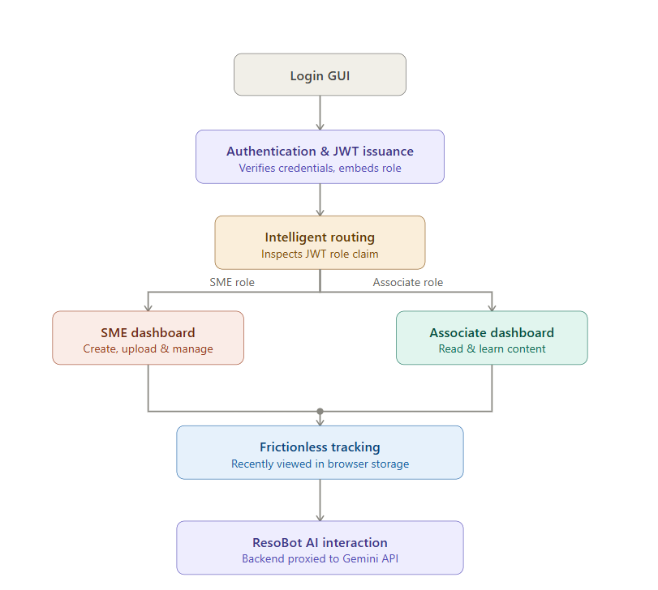
The application is designed to guide users through a secure, logical, and highly efficient workflow. Here is the step-by-step journey of data and user interaction within ResoHub:
- Secure Entry: The journey begins at the Login GUI, where a user enters their credentials.
- Authentication & Token Issuance: The backend verifies these credentials against the database. If valid, the system generates a secure JSON Web Token (JWT). This token acts as a digital ID card, securely embedding the user's specific role (SME or Associate).
- Intelligent Routing: Upon entering the portal, the frontend routing engine inspects this token.
  - The SME Path: If the system identifies the user as a Subject Matter Expert, it unlocks a suite of administrative tools. The SME gains access to creation dashboards where they can draft new modules, securely upload heavy files (handled by the Multer middleware), and manage or delete outdated content.
  - The Associate Path: If the user is an Associate, the system presents a clean, distraction-free reading dashboard focused purely on content consumption and learning.
- Frictionless Tracking: As the user interacts with the platform—whether they are clicking on a "Technical" smart filter or opening a new training video—the system quietly updates a localized "Recently Viewed" history in the browser's storage, ensuring they can easily pick up right where they left off.
- AI Interaction: When a user encounters a difficult concept, they open the integrated ResoBot. They type a question, and the frontend sends this prompt to the backend. The backend securely proxies this request to the Gemini API and streams the intelligent, context-aware answer back to the user's screen in real time.
3.5 TOOLS AND SOFTWARE USED
To bring this architecture to life, we carefully selected a stack of modern, industry-leading tools:
- Node.js & Express: These form the backbone of our server. Node.js allows us to use JavaScript on the backend, ensuring a unified language across the entire project. Express provides a lightweight framework to easily build robust API routes and handle network requests.
- React & React Router: React was chosen for its component-based architecture, allowing us to build reusable UI elements like Module Cards and navigation bars. React Router enables Single Page Application (SPA) navigation, meaning users can move between pages instantly without the browser ever needing to reload.
- Tailwind CSS: To achieve our sleek "Glassmorphism" design, we used Tailwind CSS. This utility-first framework allowed us to rapidly style components directly within our code, ensuring a highly responsive design that looks great on both large monitors and smaller laptop screens.
- Multer: Handling file uploads (like heavy PDFs and MP4s) is notoriously tricky in web development. Multer is a specialized Node.js middleware that safely intercepts these "multipart/form-data" uploads, processes them, and saves them securely to our server's file system.
- JSON Web Tokens (JWT): For security, we utilized JWTs. This allowed us to build a "stateless" authentication system. Instead of the server needing to remember who is logged in, the user's browser holds a cryptographically signed token that proves their identity and role with every single click, ensuring top-tier security with minimal server strain.

CHAPTER 4
RESULTS AND DISCUSSION

4.1 IMPLEMENTATION RESULTS
Bringing ResoHub from a conceptual architecture to a fully functional, deployed platform was a rigorous but highly rewarding process. Upon empirical execution, we were thrilled to see that the system not only met all of our predefined objectives but delivered an exceptionally smooth user experience.
The React-based Graphical User Interface (GUI) successfully loaded and, more importantly, demonstrated true dynamic rendering. Depending on the authenticated user's role, the interface intuitively morphed to present the correct dashboard, proving our conditional logic was flawless. For our Subject Matter Experts (SMEs), the platform functioned as a powerful, frictionless tool. SMEs were able to effortlessly upload heavy training assets—such as complex PDF architectural diagrams and high-definition MP4 instructional videos. These files were safely captured by the server, securely stored in the designated directories, and accurately mapped within our database without any data loss or corruption.
On the Associate side, the learning experience was transformed. The Smart Filtering system allowed users to instantly sort through dozens of modules by categories like "Technical," "Compliance," or "HR" without ever triggering a frustrating page reload. The crowning achievement of the implementation, however, was the AI Chatbot. When put to the test, the ResoBot accurately processed complex user prompts, securely communicated with the Gemini API, and returned highly contextual, easy-to-understand educational guidance. It successfully acted as the 24/7 virtual mentor we originally envisioned.
4.2 SCREENSHOTS
To visually document the success of the implementation, the following screenshots capture the core workflows and the modern "Glassmorphism" aesthetic of the ResoHub platform:
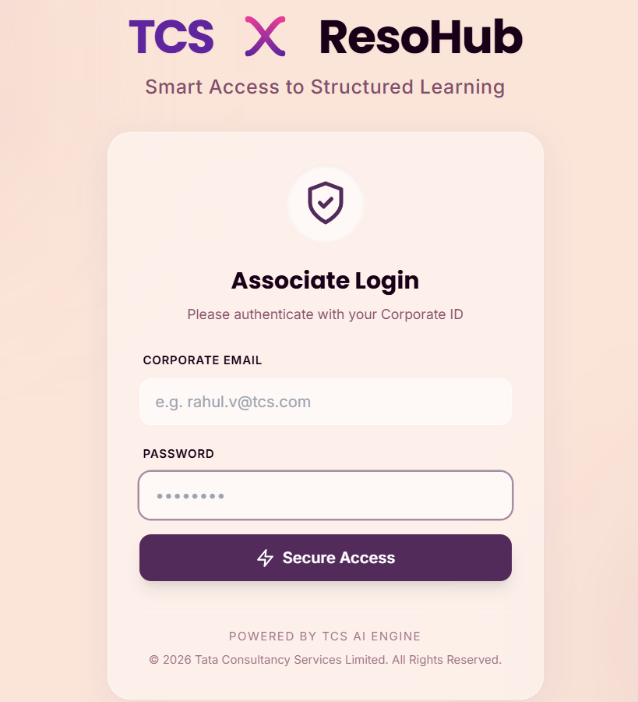
Figure 4.2a: The secure point of entry, demonstrating the clean authentication interface where users receive their role-based JWT.
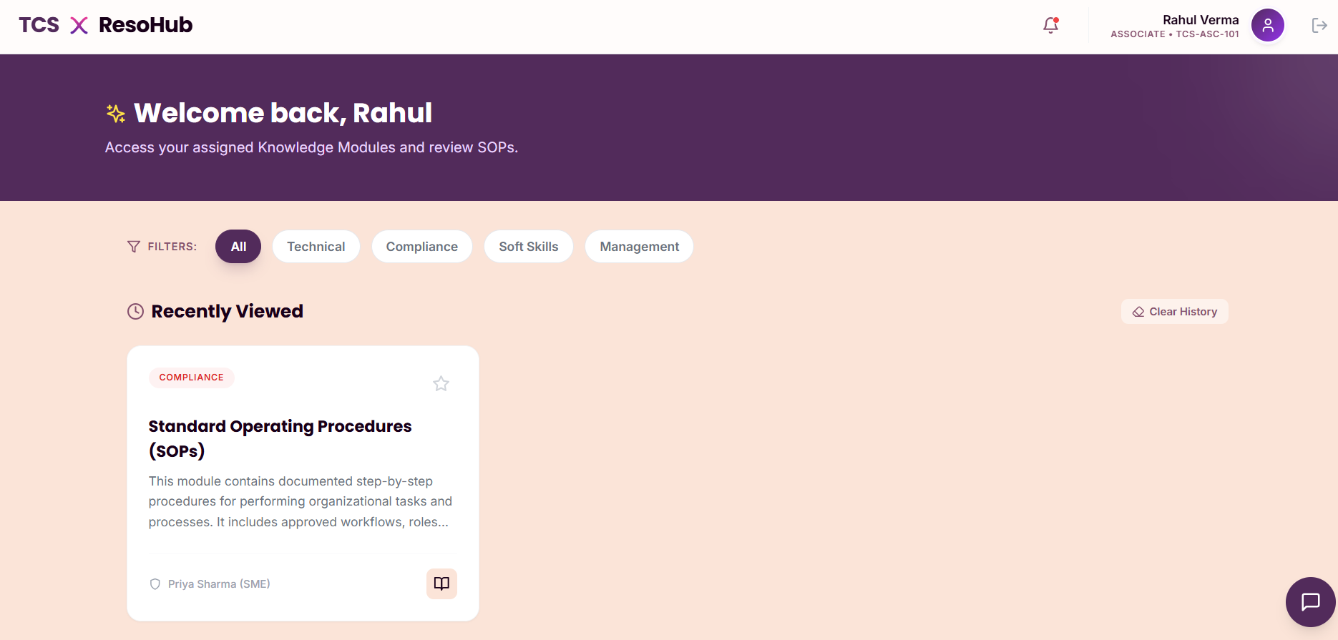Figure 4.2b: The primary learning interface, showcasing the dynamic Module Cards, the active Smart Filters, and the "Recently Viewed" history section.
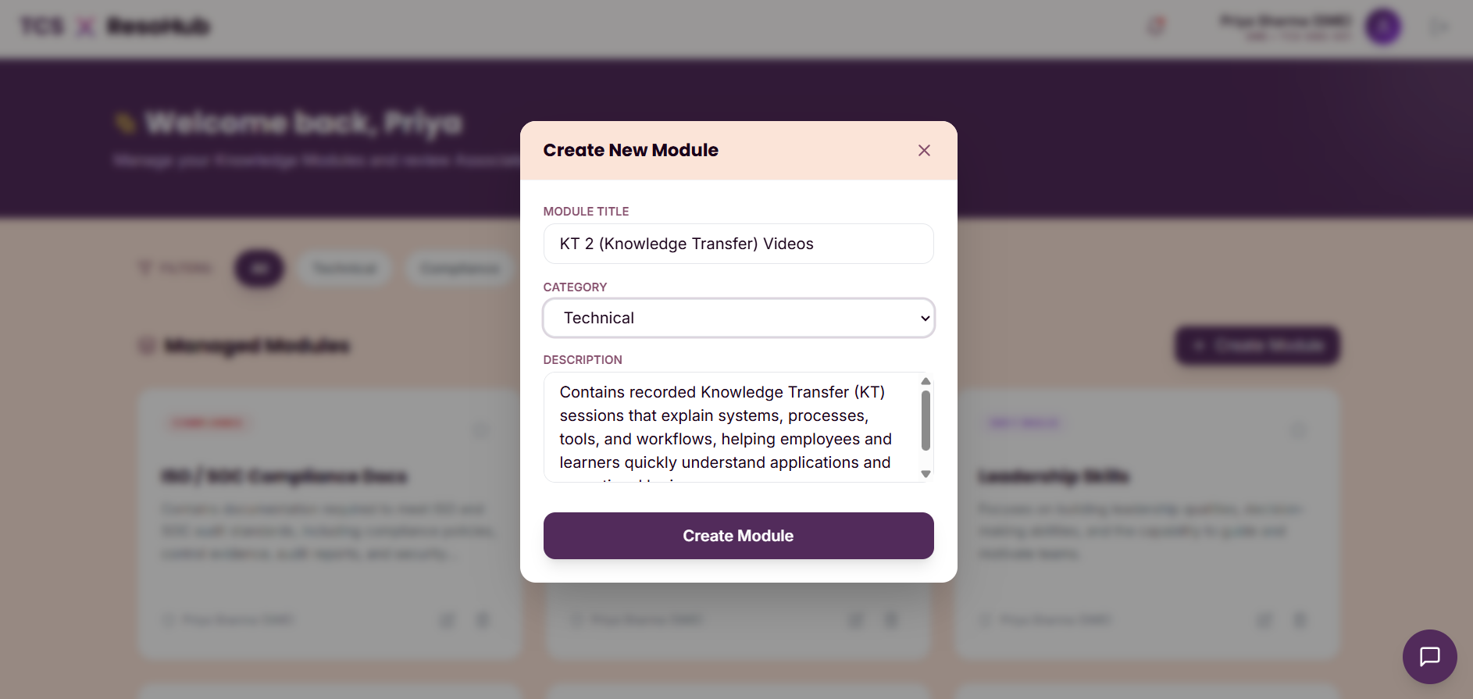Figure 4.2c: The administrative view, highlighting the intuitive, drag-and-drop file upload interface used by SMEs to populate the platform.

4.3 PERFORMANCE ANALYSIS
In modern web applications, a beautiful interface means very little if the underlying system is sluggish. Therefore, we paid close attention to how ResoHub performed under the hood, and the results were highly satisfactory across all modules.
Starting with security, the JWT-based authentication executed in mere milliseconds. From the user's perspective, logging in felt instantaneous, with zero perceived lag between hitting the "Submit" button and seeing their personalized dashboard. Once inside, the platform felt incredibly snappy. Because we implemented client-side logic for the Smart Filters, the system bypassed the need to send unnecessary query requests to the database. This meant that sorting and searching through modules happened in real-time, resulting in a perfectly fluid UI update.
We also closely monitored the backend during heavy file uploads. Thanks to the efficient handling by the Multer middleware, SMEs could upload large video assets without blocking the main Node.js server thread, ensuring that other users on the platform experienced no slowdowns. The only notable latency observed during our testing was tied to the AI Chatbot. Because the system must reach out over the network to the external Google Gemini API to generate intelligent responses, we recorded an average response time of 1 to 3 seconds. However, given the high quality and generative nature of the AI's answers, this brief pause falls well within acceptable, natural interactive limits for a conversational assistant.
4.4 DISCUSSION
The successful deployment and testing of ResoHub prove a fundamental point: the traditional, static corporate intranet is outdated. Our results clearly demonstrate that integrating a generative AI assistant directly into a Learning Management System profoundly streamlines how knowledge is retrieved. Instead of Associates spending thirty minutes hunting through a dense 50-page PDF, they can now get accurate answers in three seconds. This directly solves our core problem statement by drastically reducing the mentorship burden placed on senior developers.
Furthermore, the strict implementation of Role-Based Access Control (RBAC) proved that a platform can be incredibly open and helpful for learners while remaining highly secure on the administrative side. By isolating creation and deletion controls entirely from standard users, we ensured zero risk of unauthorized data modification or accidental deletion.
Finally, our architectural decision to utilize local browser storage for tracking "Recently Viewed" items and "Favorites" yielded unexpected dividends. It proved to be an excellent, lightweight design choice. By handling this personalization on the user's device rather than making constant database calls, we significantly reduced server overhead and database costs, all while delivering a highly customized, frictionless learning journey for the employee.

CHAPTER 5
CONCLUSION AND FUTURE SCOPE
5.1 CONCLUSION
The conceptualization, development, and successful deployment of TCS ResoHub stand as a powerful testament to how modern web frameworks and Artificial Intelligence can be leveraged to solve deeply entrenched operational bottlenecks in the corporate sector. In today's fast-moving IT industry, data is abundant, but truly accessible knowledge is scarce. This project successfully bridged that gap.
By replacing rigid, hard-to-navigate legacy file drives with an intelligent, centralized, and visually engaging portal, ResoHub fundamentally transforms the employee onboarding and continuous learning experience. It shifts the corporate culture from a reliance on manual mentorship—which inherently drains the time and productivity of senior developers—to a culture of self-sufficient, empowered learning. Associates are now equipped to instantly retrieve precise technical guidance through the AI Chatbot, thereby minimizing onboarding latency and democratizing access to critical technical training across the board.
Furthermore, this project extends beyond just corporate efficiency; it aligns with broader global sustainability targets. ResoHub directly supports the United Nations Sustainable Development Goal #4 (Quality Education) by ensuring that every employee, regardless of their physical location or project assignment, has equitable and inclusive access to high-quality training materials. Additionally, it strongly supports Goal #9 (Industry, Innovation, and Infrastructure) by actively modernizing digital corporate workflows, replacing outdated, fragmented systems with resilient, AI-integrated infrastructure built for the future.
5.2 FUTURE SCOPE
While the current iteration of ResoHub successfully achieves its core objectives, the platform was intentionally built with a modular, scalable architecture. This provides a robust foundation for several exciting avenues of future enhancement:
- Enterprise Cloud Integration: As the volume of uploaded training videos and dense architectural PDFs grows, the system's local storage can be migrated to enterprise-grade cloud solutions like AWS S3 or Google Cloud Storage. This transition would ensure global scalability, implement Content Delivery Networks (CDNs) for zero-buffering video playback across international offices, and provide automated disaster recovery.
- Retrieval-Augmented Generation (RAG): The next logical evolution for the ResoBot is to implement advanced RAG architecture. Instead of just relying on general context, the AI can be engineered to directly parse and "read" the text inside uploaded PDF documents. When an associate asks a question, the AI would not only provide the answer but also supply exact page numbers and document citations (e.g., "According to page 4 of the Cloud Deployment SOP..."), drastically increasing the trustworthiness and accuracy of the assistant.
- Advanced Analytics and Management Dashboards: To provide actionable insights for Human Resources and project managers, the platform can be expanded to include an analytics suite. This would allow leadership to track learning metrics, identify which training modules have the highest engagement and completion rates, and pinpoint which SOPs are frequently causing confusion based on chatbot query logs.
- Dedicated Mobile Application: To cater to the modern, hybrid workforce, ResoHub can be expanded beyond the desktop environment. By utilizing React Native, much of the existing React.js frontend code can be repurposed to deploy ResoHub as a dedicated mobile application for iOS and Android. This would empower employees to engage in "learning on the go," allowing them to review training materials or ask the AI questions directly from their smartphones during their commute or while away from their desks.

REFERENCES
[1] React Documentation. (2025). React: The library for web and native user interfaces. Retrieved from react.dev
[2] Node.js Foundation. (2025). Node.js API Documentation.
[3] Google Developers. (2025). Gemini API Documentation & Generative AI.
[4] Author(s). (2024). Impact of AI Chatbots in Corporate Learning Management Systems. International Journal of Educational Technology.
[5] IETF. (2015). JSON Web Token (JWT) Standard (RFC 7519).
[6] Tailwind Labs. (2025). Tailwind CSS Documentation: Utility-First Fundamentals. Retrieved from tailwindcss.com
[7] OpenJS Foundation. (2025). Express - Node.js web application framework. Retrieved from expressjs.com
[8] Author(s). (2023). Evaluating the Efficiency of Role-Based Access Control (RBAC) in Enterprise Web Applications. Journal of Information Security and Applications.
[9] Author(s). (2024). The Shift to Micro-Learning: Integrating Generative AI into Corporate Onboarding. International Journal of Corporate Education.
[10] Hipp, D. R. (2025). SQLite Documentation. Retrieved from sqlite.org

APPENDIX I
PLAGIARISM REPORT
Both similarity and AI Plagiarism duly signed by the supervisor/faculty

APPENDIX II
PROJECT OUTCOMES
: The group or Team has to showcase an any of the following outcomes (attach Proof )
- Project to Product
- Project to Hackathon Competitions, Patents, etc
- Research Oriented- Publish the work research papers in SCI indexed Journals.
- Research Oriented- Publish the work research papers in Scopus indexed Journals.
- Research Oriented- Publish the work research papers in UGC CARE List/Conference
- Patents Publication

